PCA based feature selection model to predict the insurance fraud detection

The ultimate focus of the insurance agency is the management of financial risks, since it includes a sizable amount of daily transactions. It is mandatory for the insurance industry to develop the capability of identifying the fraudulent activities with increased accuracy in order to minimize the excessive unwarranted loss due to claim leakage. Initially, many fraud detecting techniques has been introduced and it relies on the heuristics around fraud indicators, also on the checklist prepared about frauds. However, the above mentioned traditional techniques highly relies on the manual intervention. Therefore, for eliminating the above mentioned issues, the insurance companies are looking towards machine learning based fraud detection techniques. In this project, initially a block chain technique is presented as a secure network by the insurance agencies to detect, store and share different customer informations. Then, a PCA based feature selection model PC-RFC algorithm is used for classifying the insurance frauds. Additionally, to analyse the working of the proposed work, it is implemented in Python software.

Proposed System:
To successfully create a model that uses ML Algorithms that ultimately aid in detecting fraud insurance claims effectively and efficiently and help the insurance industries. Globally, there are over a thousand companies in the insurance market, and they gather premiums of over one trillion dollars annually. The most common insurance fraud is fabricating accident claims, which may be done with a vehicle. Utilizing machine learning techniques, this research aims to detect car insurance fraud.

Implementation:
Data collection: Gathering data from publically available sources for training a machine learning model is the initial stage in a machine learning pipeline. Data collection involves gathering information from diverse sources to address pertinent questions. The accuracy of the predictions generated by a model is inherently tied to the quality of the data used for its training. Challenges during data collection include unreliable data, missing data, and data imbalance.To mitigate these problems, data preprocessing is conducted on the collected data.

Data Preprocessing: Because they are fragmentary, inconsistent, and devoid of specific behavioral patterns, raw data from the real world are probably not dependable. Thus, pre-processing is done after data collection to clean up the data and prepare it for machine-learning model construction.

Data cleaning: Erroneously added or classified data can be removed manually or automatically. Imputation of data: Standard deviation, mean, and median are three common methods most machine-learning systems use to balance or fill in missing values

Oversampling: Biased or unbalanced datasets can be added to the underrepresented classes after being corrected using strategies like oversampling and repetition. Exploratory
Data Analysis: Exploratory Data Analysis, abbreviated as EDA, fundamentally serves as a form of storytelling that enables the revelation of concealed insights and patterns, the identification of outliers and anomalies, and the validation of underlying structures

1. In the initial step, we import the packages
2. Upload the CSV file (data sets)
3. We can use functions like describe and info functions tothe dataset
4. Data pre-processing i. Missing values (visualizing the missing values) ii. Handling missing values
5. Displaying correlation between features
6. Dropping the columns which are not necessary for prediction
7. Masking Multicollinearity 8. Separating the feature and target columns
9. Encoding Categorical columns
➢ Extracting categorical columns
➢ Drop Dummies
➢ Extracting the numerical columns
➢ Combining the Numerical and Categorical data frames to get the final dataset
10. Outliers Detection
11. Splitting data into training sets and test sets.
12. Scaling the numeric values in the dataset
13. Models creation and training
14. Model Performance Comparison

Literature Survey:
Rama Devi Burri et all [1] presented several machine learning techniques to analysis insurance claims efficiently. They also mentioned three ways to transform machine learning techniques into insurance industry. Additionally they specified different resistances for adapting machine learning to classify claims and challenges in implementing machine learning. Also they evaluated the performance of different algorithms for claim predictions.

Pinak Patel et all [2] proposed a fraud detection framework for health care industry. They classified the fraudulent behaviour in two categories period based claim anomalies and disease based anomalies. Their framework was evaluated on real world medical data which showed efficient results to determine fraud claims.
Sunita Mall et all [3] proposed a study to identify important triggers of fraud and to predict the fraudulent behavior of customers using those identified triggers. They used statistical techniques to identify and predict the triggers.
Najmeddine Dhieb et all [4] evaluated the performance XGBoost algorithm for detecting and classifying different types of auto insurance fraud claims. They compared the proposed algorithm with other state-of-the-art solutions. Also they evaluated the algorithms for several metrics by applying data analysis and exploration techniques.
Shimin LEI et all [5] presented an XGBoost based system for financial fraud detection. They divided system into two parts as automatic part and manual part. The automatic part used large database to train model and manual part is used to monitor the transactions. Then for making final decision they combined machine scoring and manual feedback

Requirements:
- Operating system : Windows 10/11.
- Coding Language : Python.

Advantages of Windows –11:
Windows 11 was built with developers in mind – to create a platform that provides a seamless development experience no matter what app you are building. We continue to learn from our past and understand the vision, innovation, and creativity can truly thrive when tools, features, and experiences are easy to use. That’s why we’ve taken steps to make developing on Windows easier.
WebView2 is now part of the operating system for everyone. We’ve significantly improved performance and reduced the disk footprint, memory usage, and launch time of your WebView2 apps by hard linking with the Edge browser. And, for those of you building Progressive Web Apps, we’ve improved the desktop integration and user experience with new standards-based and experimental capabilities. You can now integrate your apps more seamlessly with the desktop by customizing the titlebar, registering as a default handler for links or protocols, and even handling files on the user’s filesystem. Of course, you can continue to use offerings like Windows Terminal and our Microsoft Edge DevTools themes to match the visual experience found throughout Windows 11.

The Windows App SDK and WinUI 3 represent the latest in native app development for Windows 11, and they empower you to build the most productive desktop apps in the world. The Windows App SDK 1.0 Preview 1 brings many new developments, including support for the MSAL library, AppInstance APIs for handling and redirecting activation, AppWindow APIs for managing your window regardless of what UI stack you’re using, performance and reliability improvements, and much more.

Python With ML:
With more organizations developing AI-based applications, it’s essential to use a programming language that reduces the complexity of code and enables its easy implementation. Today, there’s a big emphasis on artificial intelligence (AI), data science, and machine learning (ML) with Python. Why? Because it offers easy-to-use and flexible tools, is extensible, has a large number of libraries, and a vast community of Python developers.

This article will examine why Python is the best choice for AI and ML and how it stacks up against other popular languages.

Huge number of libraries and frameworks
Building AI/ML applications is complex and time-consuming. However, there are many libraries that are compatible with Python. This is the primary reason developers prefer it over other languages.

Note: Libraries are pre-written pieces of code that can be reused by importing them in the editor and calling the function.

For example, the Scikit-learn library provides a number of implementations of ML algorithms like linear regression, logistic regression, support vector machines, etc. Other libraries include spaCy, Natural Language Toolkit (NLTK), etc. Meanwhile, TensorFlow, PyTorch, and Keras libraries are popular among the AI community. Several others like NumPy, Pandas, and Seaborn allow easy manipulation of data. These libraries, which are only available in Python, reduce the time and complexity of writing code.

Easy syntax and resembles the English language
Python’s syntax is simple and resembles everyday English. This reduces the time developers take to learn and understand the syntax and implement it. Moreover, Python doesn’t involve the use of brackets as it uses indentation, which again reduces complexity.

No need to recompile source code
Developers don’t need to recompile source code each and every time. Rather, they can quickly make changes and see the results. This flexibility is one of the biggest advantages of using Python.

Platform-independent
The Python code is capable of running on different platforms like Windows, Mac, UNIX, and Linux.

Great community support
Being a popular open-source programming language, Python has a large global community. The user base is eager to help and welcomes participation of all levels. This is also helpful when debugging code.

Readability
Python provides good readability of code since it uses indentation which properly structures the code.

1. Simplicity and consistency
AI algorithms and machine learning models are complex predictive technologies that Python can simplify. How? With its clear code, and lots of machine learning-specific libraries, possibility to shift focus from the language toward algorithms. Also, it is quite easy to learn, consistent, and intuitive. That’s why Python receives 3rd place as the most popular technology. 48.24% of developers gave their votes for this language.

2. Variety of libraries and frameworks
There is a vast database of libraries and frameworks that Python uses for machine learning purposes. For example,

NumPy works with arrays, in some parts of linear algebra, and different matrices.
Keras, which is a deep learning API running on TensorFlow makes it possible to experiment fast.
Tensorflow – a free open-source library for both ML and AI that focuses on training and deep neural networks.
Matplotlib is a library that allows the creation of visualizations (static, animated, interactive) in Python.
Seaborn – a data visualization library based on Python, which gives an opportunity to draw graphics (statistics), which are attractive and of high quality.
PyTorch is an open-source ML library used to build computer vision and natural language processing applications.
3. Platform independence
Software solutions developed with Python can be built and also can run on multiple operating system platforms. For instance, Linux, Windows, Mac, Solaris, and more. This makes Python programming machine learning a lot more convenient. That’s why developers enjoy Python in the process of developing ML apps.

4. Great community
Like there are communities of JavaScript lovers, there is also one belonging to Python. And, it’s huge. You can have access to almost anything you need there considering development. And, also, when you ask something there, you will always get support and answers.

These are the most prominent benefits of Python for machine learning. But there is even more to observe.

Consider Inoxoft your trusted partner
Inoxoft is an experienced leader in the software market. Our team also uses Python programming language for machine learning purposes. Thus, we have an extensive selection of machine-learning Python libraries in the development process.

Choose our machine learning development services! Get consultation on the role of Python in machine learning. Experience all the advantages of Inoxoft’s Python development services.

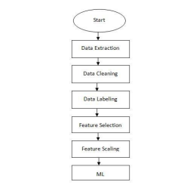

DATA FLOW DIAGRAM:

- The DFD is also called as bubble chart. It is a simple graphical formalism that can be used to represent a system in terms of input data to the system, various processing carried out on this data, and the output data is generated by this system.
- The data flow diagram (DFD) is one of the most important modeling tools. It is used to model the system components. These components are the system process, the data used by the process, an external entity that interacts with the system and the information flows in the system.
- DFD shows how the information moves through the system and how it is modified by a series of transformations. It is a graphical technique that depicts information flow and the transformations that are applied as data moves from input to output.
- DFD is also known as bubble chart. A DFD may be used to represent a system at any level of abstraction. DFD may be partitioned into levels that represent increasing information flow and functional detail.

DFD:
Pre process
Level 0:
Dataset
Attribute details
Replace missing

Level 1:
Pre process
INPUT VARIABLE
TNORM

Level 2:
IDS Resultset
Attribute Selection
Voting classifier

Level 3:
Pre-process

Performance Evaluation
Feature extraction
DATASET

classification

UML DIAGRAMS

UML stands for Unified Modeling Language. UML is a standardized general-purpose modeling language in the field of object-oriented software engineering. The standard is managed, and was created by, the Object Management Group.
The goal is for UML to become a common language for creating models of object oriented computer software. In its current form UML is comprised of two major components: a Meta-model and a notation. In the future, some form of method or process may also be added to; or associated with, UML.
The Unified Modeling Language is a standard language for specifying, Visualization, Constructing and documenting the artifacts of software system, as well as for business modeling and other non-software systems.
The UML represents a collection of best engineering practices that have proven successful in the modeling of large and complex systems.
The UML is a very important part of developing objects oriented software and the software development process. The UML uses mostly graphical notations to express the design of software projects.

GOALS:
The Primary goals in the design of the UML are as follows:
- Provide users a ready-to-use, expressive visual modeling Language so that they can develop and exchange meaningful models.
- Provide extendibility and specialization mechanisms to extend the core concepts.
- Be independent of particular programming languages and development process.
- Provide a formal basis for understanding the modeling language.
- Encourage the growth of OO tools market.
- Support higher level development concepts such as collaborations, frameworks, patterns and components.
- Integrate best practices.

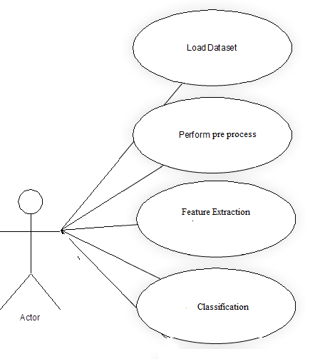

USE CASE DIAGRAM:
A use case diagram in the Unified Modeling Language (UML) is a type of behavioral diagram defined by and created from a Use-case analysis. Its purpose is to present a graphical overview of the functionality provided by a system in terms of actors, their goals (represented as use cases), and any dependencies between those use cases. The main purpose of a use case diagram is to show what system functions are performed for which actor. Roles of the actors in the system can be depicted.

SEQUENCE DIAGRAM:
A sequence diagram in Unified Modeling Language (UML) is a kind of interaction diagram that shows how processes operate with one another and in what order. It is a construct of a Message Sequence Chart. Sequence diagrams are sometimes called event diagrams, event scenarios, and timing diagrams.

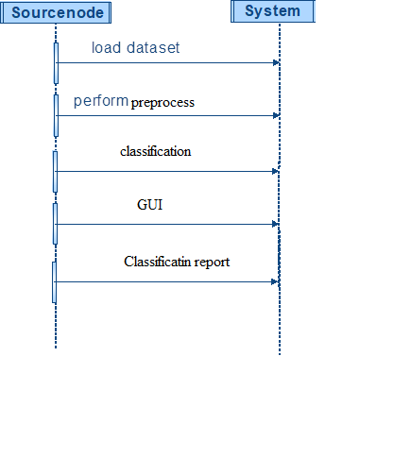

ACTIVITY DIAGRAM:
Activity diagrams are graphical representations of workflows of stepwise activities and actions with support for choice, iteration and concurrency. In the Unified Modeling Language, activity diagrams can be used to describe the business and operational step-by-step workflows of components in a system. An activity diagram shows the overall flow of control.
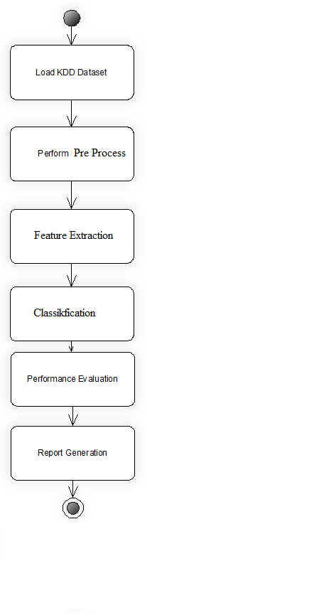

Literature Survey:
Traditionally, ICSs were in an isolated environment with the focus on safety, where each system is safeguarded to stop the process if something goes wrong. However, the introduction of Internet protocols, IoT devices, and wireless technologies within ICSs has resulted in significantly less isolation from the outside world. Consequently, safety mechanisms, which were not designed to deal with malicious attacks, face more vulnerabilities than ever before. The majority of current existing techniques on cyberattack detection in ICSs are based on traditional IDSs, which are mainly designed for IT security analysis [5] [17]. IDSs can be categorized as signature-based and learning-based techniques. Signature-based approaches use databases and fixed signatures to detect known attacks, rendering them inefficient in detecting unknown or new attacks [19]. On the other hand, learning-based systems aim to identify process trends or behaviors that increase the efficiency to manage unexpected intrusions [20]. [21] used a common-path mining method for anomaly detection in smart cyber-physical grids. An attack detection technique based on the Pearson correlation between two sensor parameters was used in [22]. Authors in [23] utilized an IDS based on the Gaussian process to the attack strategy for anomaly detection. While these approaches are effective in detecting unusual activates, they are not reliable due to frequent upgrades in the network, resulting in different IDS topologies

In contrast, learning-based IDSs are designed based on a moving target to continually evolve and learn new vulnerabilities [24] [25]. These methods try to generate the normal behavior of the system using existing datasets, then identify the irregular pattern as abnormalities. The authors of [26] proposed an anomaly detection technique based on reinforcement learning and convolutional autoencoders for ICS. Alternatively, [27] addresses the detection of Denial of Service (DoS) attacks using Support Vector Machine (SVM) and RF. [28] suggested an unsupervised technique for the effective detection of privacy attacks based on observations of eavesdropping attacks. [29] uses a variety of DNN methods, including different variants of convolutional and recurrent networks for cyber-attack detection in water treatment facilities. An ICS anomaly detection method using Long Short-term Memory (LSTM) networks is proposed in [30]. The authors of [31] proposed an attack detection techniques based on Hierarchical Neural Network. Similarly, [32] proposed a deep learning-based IDS through utilizing Recurrent Neural Networks (RNNs). In another study [33], the authors applied a stacked Nonsymmetric Deep Autoencoder (NDAE) to develop their IDS. [34] proposed an unauthorized intrusion detection technique and conducted backdoor attacks on a SCADA Industrial Internet of Things (IIoT) testbed. [35] proposed a graphical model-based approach for detecting abnormal behavior in an ICS using Bayesian networks to map the relationship between sensors and actuators. [36] implemented a toolchain with multiple state-of-the-art Anomaly Detection (AD) techniques used for detecting attacks that appear as anomalies. Their findings suggest that detection rates can change dramatically when considering different detection modes, thereby necessitating a reliable and real-time AD technique to maintain resilience in critical infrastructures. [37] proposes a genetic algorithm (GA) to find the best NN architecture for a given dataset, using the NAB metric to determine the consistency and quality of different architectures. [38] evaluates the application of unsupervised machine learning algorithms, including DNN and SVM, to detect anomalies in the Cyber-Physical System (CPS) using data from a Secure Water Treatment (SWaT)...testbed. Results indicate that the DNN classifier results in less false positives when compared to the one-class SVM, while SVM can detect more anomalies. Although the above-mentioned works addressed some of the issues related to cyber-attack detection in ICSs, most of them are heavily reliant on feature engineering. These methods are quite complicated and require sophisticated learning techniques, which can potentially increase their computational burden. Furthermore, the majority…of current proposed…techniques are. evaluated using balanced datasets, which lack the standard representation of imbalanced data in the ICS environment. Thus, it is hard to deploy such algorithms as they cannot extract various discriminative information from real-world imbalanced datasets. As such, in this paper, we propose a deep learningbased attack detection technique, which extracts a new representation from raw imbalanced datasets, for reliable and accurate attack detection with a low false-positive rate in highly imbalanced datasets from ICS environments.

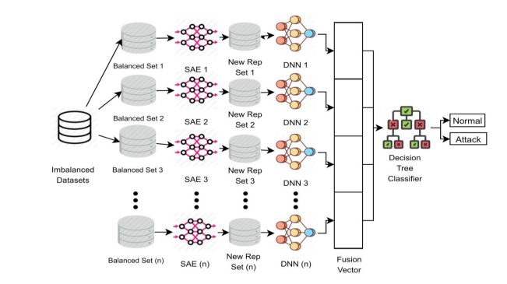

- Available for download from http://www.python.org.


Prefer a video? We have one for you.

Python Program
- Python programs are composed of modules
- Modules contain statements
- Statements contain expressions
- Expressions create and process objects

Features of Python
Open source: Python is publicly available open source software, any one can use source code that doesn't cost anything.
Easy-to-learn: Popular (scripting/extension) language, clear and easy syntax, no type declarations, automatic memory management, high-level data types and operations, design to read (more English like syntax) and write (shorter code compared to C, C++, and Java) fast.
High-level Language:
High-level language (closer to human) refers to the higher level of concept from machine language (for example assembly languages). Python is an example of a high-level language like C, C++, Perl, and Java with low-level optimization.
Portable:
High level languages are portable, which means they are able to run across all major hardware and software platforms with few or no change in source code. Python is portable and can be used on Linux, Windows, Macintosh, Solaris, FreeBSD, OS/2, Amiga, AROS, AS/400 and many more.
Object-Oriented: Python is a full-featured object-oriented programming language, with features such as classes, inheritance, objects, and overloading.
Python is Interactive :
Python has an interactive console where you get a Python prompt (command line) and interact with the interpreter directly to write and test your programs. This is useful for mathematical programming.
Interpreted : Python programs are interpreted, takes source code as input, and then compiles (to portable byte-code) each statement and executes it immediately. No need to compiling or linking
Extendable : Python is often referred to as a "glue" language, meaning that it is capable to work in mixed-language environment. The Python interpreter is easily extended and can add a new built-in function or modules written in C/C++/Java code.
Libraries : Databases, web services, networking, numerical packages, graphical user interfaces, 3D graphics, others.
Supports :Support from online Python community

Python Interpreter
- In interactive mode, type Python programs and the interpreter displays the result:
- Type python into your terminal's command line
- After a short message, the >>> symbol will appear
- The above symbol signals the start of a Python interpreter's command line.
- Python interpreter evaluates inputs (For example >>> 4*(6-2) return 16)

How stable is Python?
Very stable. New, stable releases have been coming out roughly every 6 to 18 months since 1991, and this seems likely to continue. Currently there are usually around 18 months between major releases.
The latest stable releases can always be found on the Python download page. There are two recommended production-ready versions at this point in time, because at the moment there are two branches of stable releases: 2.x and 3.x. Python 3.x may be less useful than 2.x, since currently there is more third party software available for Python 2 than for Python 3. Python 2 code will generally not run unchanged in Python 3.

History
The name Python was selected from "Monty Python�s Flying Circus" which was a British sketch comedy series created by the comedy group Monty Python and broadcast by the BBC from 1969 to 1974.
Python was created in the early 1990s by Guido van Rossum at the National Research Institute for Mathematics and Computer Science in Netherlands.
Python was created as a successor of a language called ABC (All Basic Code) and released publicly in1991. Guido remains Python's principal author, although it includes many contributions from active user community.
Between 1991 and 2001 there are several versions released, current stable release is 3.2. In 2001 the Python Software Foundation (PSF) was formed, a non-profit organization created specifically to own Python-related Intellectual Property. Zope Corporation is a sponsoring member of the PSF.
All most all Python releases are Open Source. To see the details of release versions and licence agreement of Python check here.

Python Is Easy to Use
A simple program written in C++, C, Java and Python. All program prints "Hello world".
C++ Program :
#include<iostream>
intmain()
{
std::cout <<"Hello World"<< std::endl;
return0;
}
Copy
C Program :
#include<stdio.h>
intmain(int argc,char** argv)
{
printf(“Hello, World!\n”);
}
Copy
Java Program :
publicclassHello
{
publicstaticvoidmain(String argv[])
{
System.out.println(“Hello, World!”);
}
}
Copy
Python Program:
print("Hello World")
Copy

Python introduction video

Python Environment
AIX | AROS | AS/400 (OS/400) | BeOS
MorphOS | MS-DOS | OS/2 | OS/390 and z/OS
Palm OS | PlayStation and PSP | Psion | QNX
RISC OS | Series 60 | Solaris | VMS
Windows CE or Pocket PC | HP-UX | Linux

Major uses of Python
- System utilities (system admin tools, command line programs).
- Web Development.
- Graphical User Interfaces (Tkinter, gtk, Qt).
- Internet scripting.
- Embedded scripting.
- Database access and programming.
- Game programming.
- Rapid prototyping and development.
- Distributed programming

Organizations Using Python (sector wise)
Web Development : Yahoo Maps, Yahoo Groups, Google, Zope Corporation, Ultraseek, Linux Weekly News, ElasticHosts Cloud Servers, Mojam.com, hunch, Shopzilla, Movieplayer.it, Multiplayer.it.
Games: Battlefield 2, Crystal Space, Star Trek Bridge Commander, The Temple of Elemental Evil, Vampire: The Masquerade: Bloodlines, Civilization 4, QuArK (Quake Army Knife)
Graphics : Industrial Light & Magic, Walt Disney Feature Animation, HKS, Inc. (ABAQUS/CAE), RoboFog, Caligari Corporation, Blender 3D, Jasc Software, Paint Shop Pro.
Financial : Altis Investment Management, ABN AMRO Bank, Treasury Systems, Bellco Credit Union, Journyx Timesheet and Resource Management Software.
Science : National Weather Service, Radar Remote Sensing Group, Applied Maths, Biosoft, The National Research Council of Canada, Los Alamos National Laboratory (LANL) Theoretical Physics Division, AlphaGene, Inc., LLNL, NASA, Swedish Meteorological and Hydrological Institute (SMHI), Environmental Systems Research Institute (ESRI), Objexx Engineering, Nmag Computational Micromagnetics
Electronic Design Automation: Ciranova, Productivity Design Tools, Object Domain, Pardus, Red Hat, SGI, Inc., MCI Worldcom, Nokia,
Education : University of California, Irvine, Smeal College of Business, The Pennsylvania State University, New Zealand Digital Library, IT Certification Exam preparation, SchoolTool,
Business Software : Raven Bear Systems Corporation, Thawte Consulting, Advanced Management Solutions Inc., IBM, Arakn<E9>, RealNetworks, dSPACE, Escom, The Tiny Company, Nexedi, Piensa Technologies - Bufete Consultor de Mexico, Nektra, WuBook.

Is Python a good language for beginning programmers?
Yes. It is still common to start students with a procedural and statically typed language such as Pascal, C, or a subset of C++ or Java. Students may be better served by learning Python as their first language. Python has a very simple and consistent syntax and a large standard library and, most importantly, using Python in a beginning programming course lets students concentrate on important programming skills such as problem decomposition and data type design. With Python, students can be quickly introduced to basic concepts such as loops and procedures. They can probably even work with user-defined objects in their very first course.
For a student who has never programmed before, using a statically typed language seems unnatural. It presents additional complexity that the student must master and slows the pace of the course. The students are trying to learn to think like a computer, decompose problems, design consistent interfaces, and encapsulate data. While learning to use a statically typed language is important in the long term, it is not necessarily the best topic to address in the students’ first programming course.
Many other aspects of Python make it a good first language. Like Java, Python has a large standard library so that students can be assigned programming projects very early in the course that do something. Assignments aren’t restricted to the standard four-function calculator and check balancing programs. By using the standard library, students can gain the satisfaction of working on realistic applications as they learn the fundamentals of programming. Using the standard library also teaches students about code reuse. Third-party modules such as PyGame are also helpful in extending the students’ reach.

SYSTEM TESTING

TESTING METHODOLOGIES

The following are the Testing Methodologies:

- Unit Testing.
- Integration Testing.
- User Acceptance Testing.
- Output Testing.
- Validation Testing.

Unit Testing

Unit testing focuses verification effort on the smallest unit of Software design that is the module. Unit testing exercises specific paths in a module’s control structure to
ensure complete coverage and maximum error detection. This test focuses on each module individually, ensuring that it functions properly as a unit. Hence, the naming is Unit Testing.
During this testing, each module is tested individually and the module interfaces are verified for the consistency with design specification. All important processing path are tested for the expected results. All error handling paths are also tested.

Integration Testing

Integration testing addresses the issues associated with the dual problems of verification and program construction. After the software has been integrated a set of high order tests are conducted. The main objective in this testing process is to take unit tested modules and builds a program structure that has been dictated by design.

The following are the types of Integration Testing:

- Top Down Integration

This method is an incremental approach to the construction of program structure. Modules are integrated by moving downward through the control hierarchy, beginning with the main program module. The module subordinates to the main program module are incorporated into the structure in either a depth first or breadth first manner.
In this method, the software is tested from main module and individual stubs are replaced when the test proceeds downwards.

2. Bottom-up Integration

This method begins the construction and testing with the modules at the lowest level in the program structure. Since the modules are integrated from the bottom up, processing required for modules subordinate to a given level is always available and the need for stubs is eliminated. The bottom up integration strategy may be implemented with the following steps:

- The low-level modules are combined into clusters into clusters that perform a specific Software sub-function.
- A driver (i.e.) the control program for testing is written to coordinate test case input and output.
- The cluster is tested.
- Drivers are removed and clusters are combined moving upward in the program structure

The bottom up approaches tests each module individually and then each module is module is integrated with a main module and tested for functionality.

7.1.3 User Acceptance Testing

User Acceptance of a system is the key factor for the success of any system. The system under consideration is tested for user acceptance by constantly keeping in touch with the prospective system users at the time of developing and making changes wherever required. The system developed provides a friendly user interface that can easily be understood even by a person who is new to the system.

7.1.4 Output Testing

After performing the validation testing, the next step is output testing of the proposed system, since no system could be useful if it does not produce the required output in the specified format. Asking the users about the format required by them tests the outputs generated or displayed by the system under consideration. Hence the output format is considered in 2 ways – one is on screen and another in printed format.

7.1.5 Validation Checking
Validation checks are performed on the following fields.

Text Field:

The text field can contain only the number of characters lesser than or equal to its size. The text fields are alphanumeric in some tables and alphabetic in other tables. Incorrect entry always flashes and error message.

Numeric Field:

The numeric field can contain only numbers from 0 to 9. An entry of any character flashes an error messages. The individual modules are checked for accuracy and what it has to perform. Each module is subjected to test run along with sample data. The individually tested modules are integrated into a single system. Testing involves executing the real data information is used in the program the existence of any program defect is inferred from the output. The testing should be planned so that all the requirements are individually tested.

A successful test is one that gives out the defects for the inappropriate data and produces and output revealing the errors in the system.

Preparation of Test Data

Taking various kinds of test data does the above testing. Preparation of test data plays a vital role in the system testing. After preparing the test data the system under study is tested using that test data. While testing the system by using test data errors are again uncovered and corrected by using above testing steps and corrections are also noted for future use.

Using Live Test Data:

Live test data are those that are actually extracted from organization files. After a system is partially constructed, programmers or analysts often ask users to key in a set of data from their normal activities. Then, the systems person uses this data as a way to partially test the system. In other instances, programmers or analysts extract a set of live data from the files and have them entered themselves.

It is difficult to obtain live data in sufficient amounts to conduct extensive testing. And, although it is realistic data that will show how the system will perform for the typical processing requirement, assuming that the live data entered are in fact typical, such data generally will not test all combinations or formats that can enter the system. This bias toward typical values then does not provide a true systems test and in fact ignores the cases most likely to cause system failure.

Using Artificial Test Data:

Artificial test data are created solely for test purposes, since they can be generated to test all combinations of formats and values. In other words, the artificial data, which can quickly be prepared by a data generating utility program in the information systems department, make possible the testing of all login and control paths through the program.

The most effective test programs use artificial test data generated by persons other than those who wrote the programs. Often, an independent team of testers formulates a testing plan, using the systems specifications.

The package “Virtual Private Network” has satisfied all the requirements specified as per software requirement specification and was accepted.

7.2 USER TRAINING

Whenever a new system is developed, user training is required to educate them about the working of the system so that it can be put to efficient use by those for whom the system has been primarily designed. For this purpose the normal working of the project was demonstrated to the prospective users. Its working is easily understandable and since the expected users are people who have good knowledge of computers, the use of this system is very easy.

7.3MAINTAINENCE

This covers a wide range of activities including correcting code and design errors. To reduce the need for maintenance in the long run, we have more accurately defined the user’s requirements during the process of system development. Depending on the requirements, this system has been developed to satisfy the needs to the largest possible extent. With development in technology, it may be possible to add many more features based on the requirements in future. The coding and designing is simple and easy to understand which will make maintenance easier.

TESTING STRATEGY :

A strategy for system testing integrates system test cases and design techniques into a well planned series of steps that results in the successful construction of software. The testing strategy must co-operate test planning, test case design, test execution, and the resultant data collection and evaluation .A strategy for software testing must accommodate low-level tests that are necessary to verify that a small source code segment has been correctly implemented as well as high level tests that validate major system functions against user requirements.

Software testing is a critical element of software quality assurance and represents the ultimate review of specification design and coding. Testing represents an interesting anomaly for the software. Thus, a series of testing are performed for the proposed system before the system is ready for user acceptance testing.

SYSTEM TESTING:
Software once validated must be combined with other system elements (e.g. Hardware, people, database). System testing verifies that all the elements are proper and that overall system function performance is
achieved. It also tests to find discrepancies between the system and its original objective, current specifications and system documentation.

UNIT TESTING:

In unit testing different are modules are tested against the specifications produced during the design for the modules. Unit testing is essential for verification of the code produced during the coding phase, and hence the goals to test the internal logic of the modules. Using the detailed design description as a guide, important Conrail paths are tested to uncover errors within the boundary of the modules. This testing is carried out during the programming stage itself. In this type of testing step, each module was found to be working satisfactorily as regards to the expected output from the module.

In Due Course, latest technology advancements will be taken into consideration. As part of technical build-up many components of the networking system will be generic in nature so that future projects can either use or interact with this.The future holds a lot to offer to the development and refinement of this project.
Screen Shots: -
Sample Code:
Conclusion:
The pursuit of effective fraud detection in insurance claims has been significantly enhanced by the integration of machine learning methodologies. Through this research, a profound exploration into the application of diverse machine learning models for fraud identification in insurance claims has been undertaken, yielding several pivotal insights and implications. The findings underscore the capability of machine learning models to discern fraudulent activities amidst complex and diverse insurance claim datasets. Various models exhibited substantial performance, as evidenced by robust metrics such as accuracy, precision, recall, F1-score, and Accuracy The identification of influential features elucidated crucial patterns and attributes crucial for distinguishing fraudulent from legitimate claims, augmenting the interpretability of model decisions. However, amidst the accomplishments, challenges emerged. The intricacies of handling imbalanced datasets, the delicate balance between model complexity and interpretability, and ethical considerations regarding fairness and privacy necessitate continued attention and refinement in future endeavors. The amalgamation of machine learning techniques for insurance fraud claim detection represents a transformative paradigm, promising a substantial shift towards proactive and effective fraud mitigation strategies within the insurance landscape.

REFERENCES
[1]” Insurance Claim Analysis Using Machine Learning Algorithms” – Rama Devi Burri et all, IJITEE 2019 https://www.ijitee.org/wpcontent/uploads/papers/v8i6s 4/F11180486S419.pdf
[2]” A Survey Paper on Fraud Detection and Frequent Pattern Matching in Insurance claims using Data Mining Techniques” – Pinak Patel et all, IRJET 2019 https://www.irjet.net/archives/V6/i1/IRJET-V6I1104.pdf
[3]” Management of Fraud: Case of an Indian Insurance Company” – Sunita Mall et all, Accounting and Finace Research 2018 http://www.sciedu.ca/journal/index.php/%20afr/article /download/13474/8333 [4]” Extreme Gradient Boosting Machine Learning Algorithm for Safe Auto Insurance operations” – Najmeddine Dhieb, et all, LCVES 2019 https://www.researchgate.net/publication/337508754_E xtreme_Gradient_Boosting_Machine_Learning_Algorithm_F or_Safe_Auto_Insurance_Operations

[5]” An XGBoost Based System for Financial Fraud Detection” – Shimin Lei, et all, E3S Web of Conferences 2020 https://www.e3sconferences.org/articles/e3sconf/pdf/2 020/74/e3sconf_ebldm2020_02042.pdf

